**WireFrame:**

**Main Menu Screen:**

* The main menu screen is the initial screen that displays the available banking options to the user.
* It can be a simple textual menu with numbered options, such as:

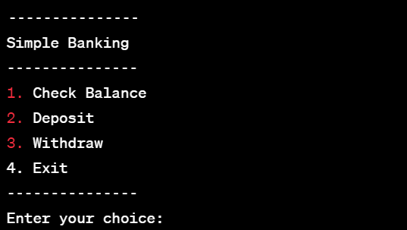

**Check Balance Screen:**

* The check balance screen displays the user's current balance.
* It can be a simple textual screen with a message like:

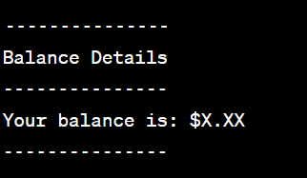

**Deposit Screen:**

* The deposit screen prompts the user to enter the amount they want to deposit.
* It can be a simple textual screen with a message and an input field, like:

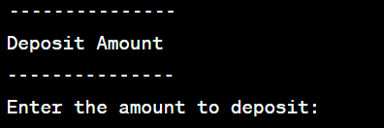

**Withdraw Screen:**

* The withdraw screen prompts the user to enter the amount they want to withdraw.
* It can be a simple textual screen with a message and an input field, like:

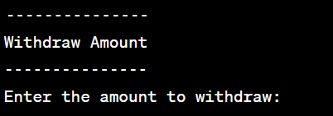

**Error Messages:**

• Error messages are displayed when invalid inputs or errors occur during the banking operations.

• They can be simple textual messages, such as:

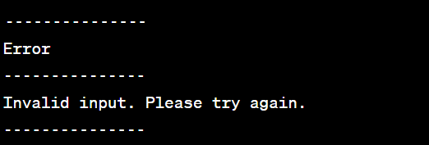

Note:

Wireframes typically represent the visual layout and structure of an application. Since the Simple Banking Application is a console-based application, the wireframe will primarily consist of textual screens and messages rather than graphical elements.